Lab#03

**Objective:** To learn RMI basics: Generate the stubs and skeletons and run client and server.

**Task1:** Create RMI program in which server performs basic arithmetic operations.

**Interface:**

import java.rmi.*;

public interface AirthmaticInterface extends Remote{

public int addNumbers(int num1,int num2)throws RemoteException;

}

**Remote Object Class:**

import java.rmi.*;

import java.rmi.server.*;

public class AirthmaticImpl extends UnicastRemoteObject implements AirthmaticInterface{

public AirthmaticImpl()throws RemoteException{

}

public int addNumbers(int num1,int num2)throws RemoteException{

int sum=num1+num2;

return sum;

}

}

**Server Class:**

import java.rmi.*;

public class MainServer{

public static void main(String args[]){

try{

Naming.rebind("rmi://localhost/MainServer",new AirthmaticImpl());

System.out.println("Server is ready");

}catch(Exception e){

System.out.println(e);

}

}

}

**Client Class:**

import java.rmi.*;

class MainClient{

public static void main(String args[]){

try{

String name="rmi://localhost/MainServer";

AirthmaticInterface ai;

ai=(AirthmaticInterface)Naming.lookup(name);

System.out.println("sum of two numbers are:"+ai.addNumbers(9,10));

}catch(Exception e){

System.out.println(e);

}

}

}

**OutPut:**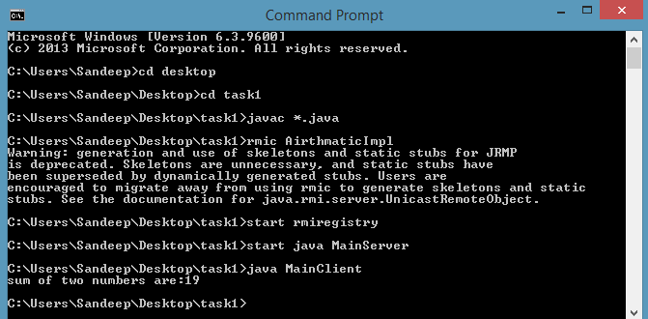

**Task2:**Create RMI program in which server sorts the numbers in ascending order.

**Interface:**

import java.rmi.*;

import java.util.*;

public interface SortNumber extends Remote{

public ArrayList applySorting()throws RemoteException;

}

**Remote Object Class:**

import java.rmi.*;

import java.rmi.server.*;

import java.util.*;

public class SortNumberImpl extends UnicastRemoteObject implements SortNumber{

public SortNumberImpl()throws RemoteException{

}

public ArrayList applySorting(){

ArrayList list=new ArrayList();

int [] data={20,4,45,10,11,23,8};

Arrays.sort(data);

for(int i=0; i<data.length; i++){

System.out.print(data[i]+" ");

list.add(data[i]);

}

return list;

}

}

**Server Class:**

import java.rmi.*;

public class SortingServer{

public static void main(String args[]){

try{

Naming.rebind("rmi://localhost/SortingServer",new SortNumberImpl());

System.out.println("server is ready");

}catch(Exception e){

System.out.println(e);

}

}

}

**Client Class:**

import java.rmi.*;

import java.util.*;

class SortingClient{

public static void main(String args[]){

SortNumber number;

ArrayList list=new ArrayList();

String name="rmi://localhost/SortingServer";

try{

number=(SortNumber)Naming.lookup(name);

System.out.println("Before sorting:20,4,45,10,11,23,8");

list=number.applySorting();

System.out.println("After sorting:"+list);

}catch(Exception e){

System.out.println(e);

}

}

}

**Output:**

